Bilkent University

Department of Computer Engineering



**CS 319 – Object Oriented Software Engineering**

CS 319 Project: Catch the Deadline

Final Report

**GROUP 2D**

Argert Boja, Bikem Çamli, Hareem Larik, Umut Ak

Course Instructor: Bora Güngören Progress/Final Report

Design Draft Report December 16, 2017

Contents

1. Introduction 3

2. Changes in the project 4

2.1 Changes in Implementation 4

2.2 Changes in UI 5

2.3 Changes in Database 5

3. Status of the Project 5

3.1 What’s Left 6

4. User’s guide 6

4.1 System Requirements 6

4.2 Installation 7

4.3 Overview of the game 7

4.4 Game Objects Management System 7

4.4.1. Controls 7

4.4.2. Objects 8

4.5 Game Screens 9

# 1. Introduction

"Catch The Deadline" is a 2D arcade-style platformer game. This game is designed to entertain its users, hence in order to do this we have included a variety of power-ups to collect and various obstacles to overcome. The game includes three levels, so that the user can have different experiences in the game and enjoy it more. To pass the levels, user should take the power-ups, in order not to loose any life and pass the enemies and obstacles in the provided time. Apart from the ordinary 2D games, "Catch the Deadline" will also be played online so that users can compete with their friends. The purpose of the game is to score the highest scores, and in order to achieve this, the user should finish the game as quick as possible and collect as much power-ups as possible. Before starting the game, a user will decide to either play with an account or play as a guest. If the user creates an account for the "Catch The Deadline" their scores will be saved and they can compete with other users. However, if a player choose to play as a guest their scores will not be saved.

The game is implemented using Java and is designed for PC usage. However the structure of the system that we chose will allow us to easily implement this game also for mobile phones. By only making changes in the User Interface classes, and keeping the same database and game logic we will be able to implement this game even for other platforms.

Overall, "Catch the Deadline" is for all the gamers that love to play arcade games. With different power-ups and weapons, players can get different experiences while playing this game. The idea behind this project is also to provide a message, that catching the deadline will not be a success only for this game, but it will also be a success for our student life.

# 2. Changes in the project

Completing a full project in such a short time, would definitely lead to a not fully complete project design. Hence during our implementation, we have done some changes that we hadn’t thought about before. Furthermore we also did some changes in order to increase the performance of the game. We added some private attributes and functions which increased the interaction between classes. Furthermore, since we worked with JFrame and ActionListeners we tried to avoid as much as possible inheritance from our classes. However we tried to follow our object design as much as possible. Detailed explanation will be given in the following sections.

One change that we did to our project was adding a store for the new weapons. In this way, the player can get new weapons in order to kill the enemies faster and hence save time to end the game earlier and score more points.

## 2.1 Changes in Implementation

**Game Manager Subsystem:**

We followed the subsystem design that we submitted on our design report. The implementation of our game was completely based on the subsystem design which was done in the second iteration design report.

### 2.2 Changes in UI

UI of our game is almost identical to the mockup that we provided in our previous reports. In addition to what we had provided, we added the Store UI which provides to the user the view in which the player can buy the new weapons.

### 2.3 Changes in Database

Since the “.jar” file cannot easily interact with an embedded database, we decided to make the database online. Beside this change, we didn’t change the structure of the DBInterface class. However, as mentioned above, due to the very limited time, this implementation might not be in its best way possible. However, the “play as guest” option, will still provide the possibility to play this game offline.

# 3. Status of the Project

Until now, we have implemented almost every feature of the game. Our game provides all the functionalities that we have mentioned in our previous reports.

### 3.1 What’s Left

There will be several thing that we will add in the project.

* Adding more features to the enemies
* Add more sound features

# 4. User’s guide

### 4.1 System Requirements

“Catch the deadline” is implemented in Java platform. Therefore, to play the game an operating system that supports JRE such as Windows, MacOS, Linux and Polaris is required. Additionally, the updated version of Java (Java 8) and JDK will be required to run the game. Furthermore, they should be configured correctly so that the game runs successfully. If the user will play online, a DSL connection is required. Otherwise the user can only play offline.

**Minimum System Requirements:**

* Java is compatible with Windows 7, 8, 10 and Windows server 2008, 2012 Mac OS X 10.8.3+, 10.9+
* A 128 MB RAM is needed
* A 124 MB Disk space is needed for JRE ( Java Runtime Environments)
* A 2 MB disk space needed for Java Update
* The computer should have a minimum Pentium 2 266 MHz CPU

### 4.2 Installation

There is no installation required to play our game. Since the game is in “.jar” format, there is no need to make any installation. In order to run the game, the user should only run the “.jar” which is provided in our GitHub folder.

### 4.3 Overview of the game

“Catch the Deadline” is a 2D arcade-style platformer game. After choosing to play either with an account or as a guest, the player will can click on the Play button on the main menu and then chose the level. The player can control the student character to collect powerups, weapons and finish the game within the provided time to catch the deadline. Player has three lives which he can lose in several ways. Firstly, if player runs out of food or sleep stocks, a life will be lost immediately. Secondly, if the user fails to finish the game within the provided time, he will again loose another life. Also the character might get killed by one of the enemies of the game. The aim of the player is to finish all of the levels as quicker as possible to get the highest score.

### 4.4 Game Objects Management System

#### 4.4.1. Controls

* Up Arrow: Jump
* Left Arrow: Run left
* Right Arrow: Run right
* A: Attack with pen
* S: Attack with eraser
* D: Attack with paint spray
* Space: Jump

#### 4.4.2. Objects

* Homework: It is one of the enemies of our game. This enemy has 5 lives.
* Exam: It is an enemy This enemy has 8 lives and it is the enemy with the largest amount of lives in our game. This enemy can easily be killed if the player posesses a pen weapon.
* Blank Sheet: It is an enemy of our game and it has 3 lives. If the player posses the PaintSpray weapon this enemy can directly be killed.
* Pen: It is a weapon to shoot the enemies and it has a power of 4. This is the most useful weapon which can destroy the exam enemy easily.
* Eraser: It is a weapon to shoot the enemies and it is the weapon with the least power.
* Paint Spray: It is a weapon to shoot the enemies and it has an average power. By using this weapon, the blank sheet can be destroyed directly..
* Sleep: It is a power-up. If user runs out of sleep one life will be lost.
* Food: It is a power-up. If user runs out of food one life will be lost.
* Coin: It is a power-up. User can collect these and improve their weapons. Furthermore, at the end of the game, the collected foods, sleep and remaining time are converted to coins which the user can use to buy wepons.

### 4.5 Game Screens

**Login Screen:**

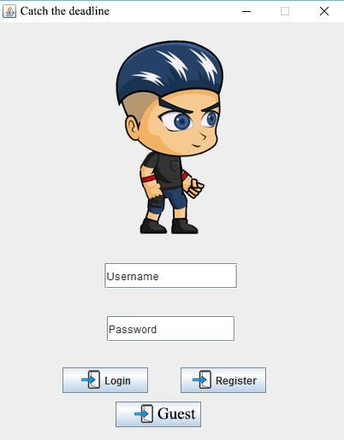

The login screen of the game. The player can choose either to login or play as a guest.

**Main Menu**

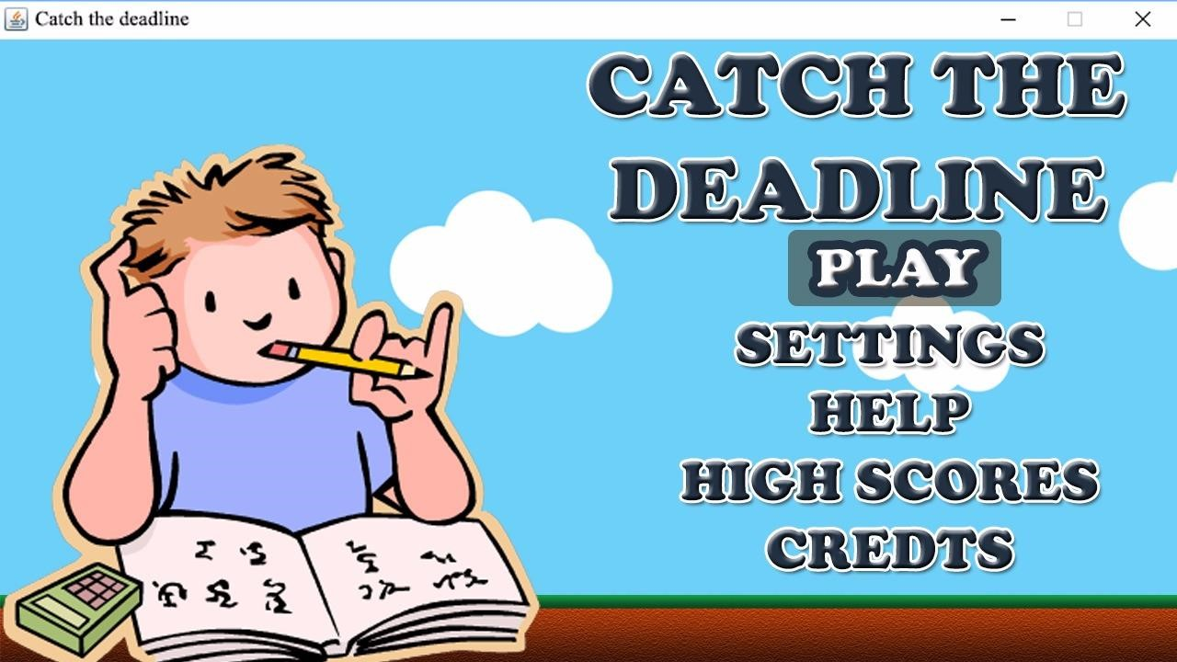

The Main Menu provides some different options to go through. Play button lets the user to go through the game and start playing it. Settings button provides user to make their own configurations about the game. In high scores, as the name suggests, the user can see all high scores including other players’ scores' if the user is playing online. In credits part, user will see the developers of the game and in the help option there is provided information about the game and guide on how to play it.

**GamePlay Screen:**

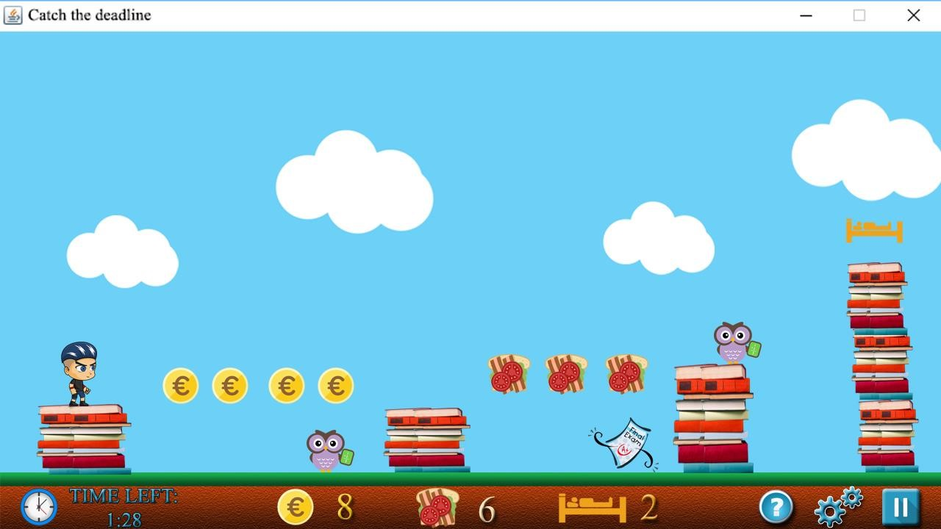

After the player pushes the play button the gameplay screen will appears. In our gameplay screen there are coins to collect which can be used to improve the weapons. Foods and sleeps are the other power-ups provided. User can go to the setting, pause game and help screens by clicking the buttons at the bottom right corner.

**Choose Level Screen:** Player can choose from three difficulty levels.

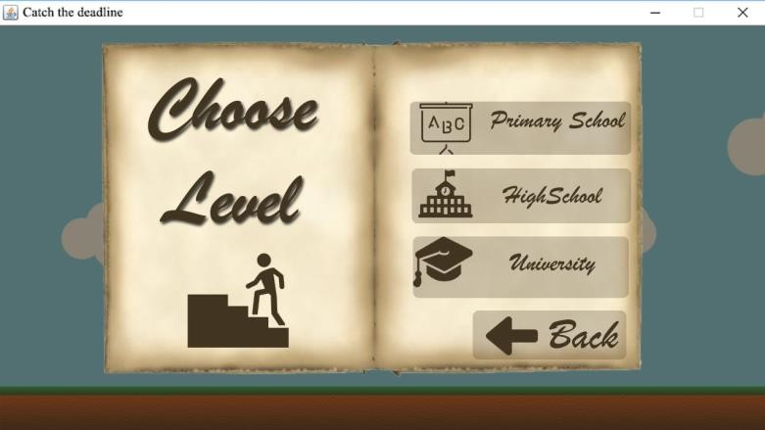

**Help Screen:** Player can use this menu to get the information about how to play the game.

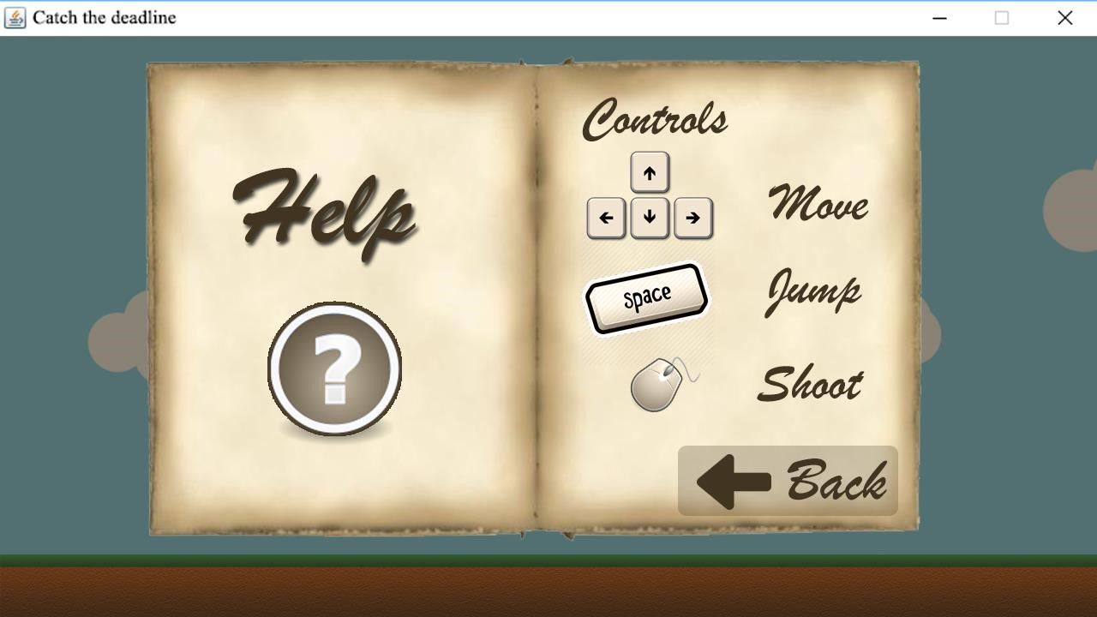

**High Score Screen:** This screen shows the highest 5 scores.

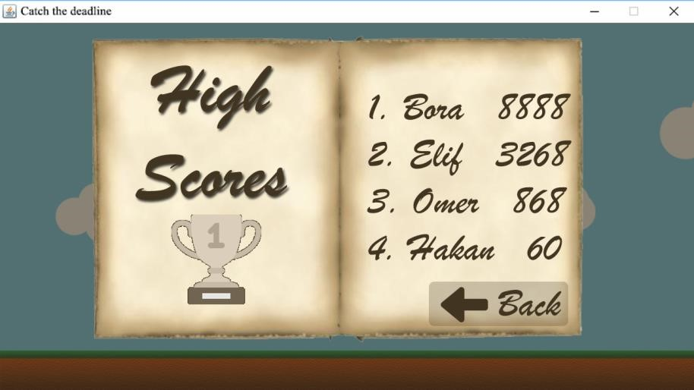

**Credits Screen:** From this screen user can see the implementers of the project.

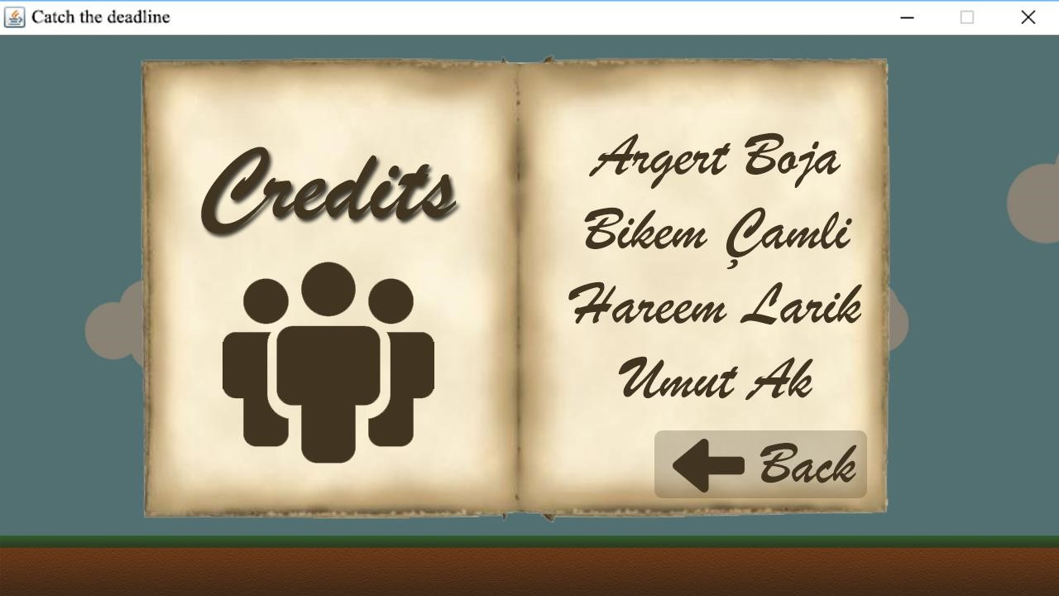

**Pause Game Menu**

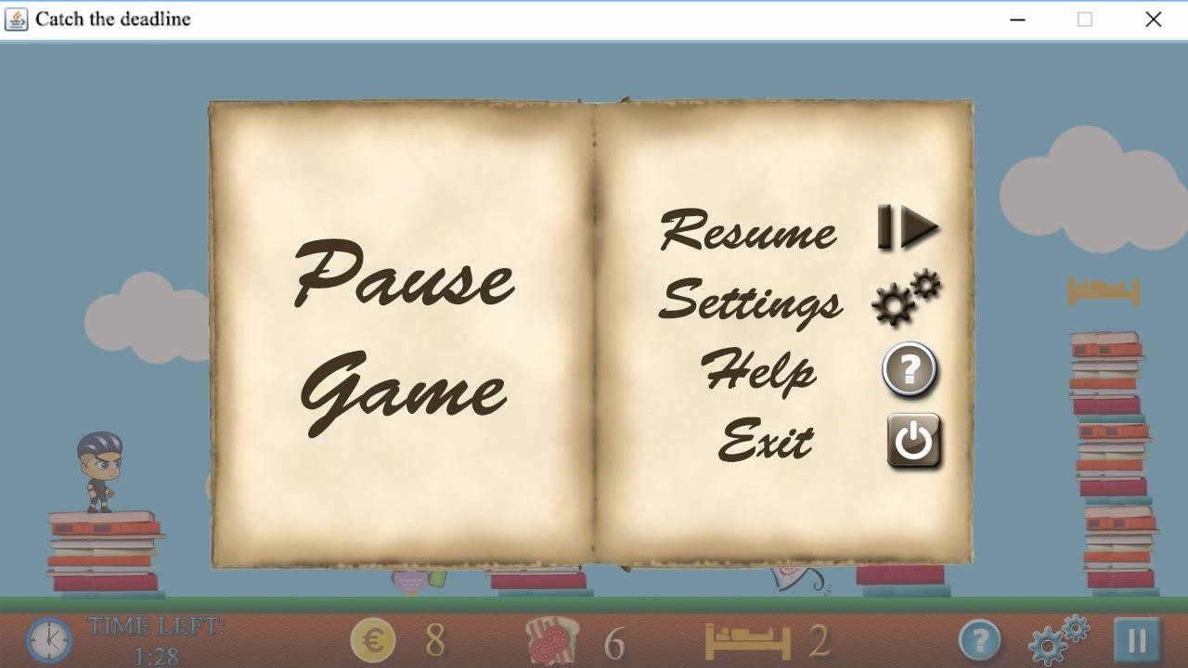

During the playtime, the user is able to pause the game. If user wants just a break, he can pause the game and they can continue from where they left. In addition, user can go to the settings menu to change configurations. Moreover, user can go through the help menu to check on how to play the game. By just pressing exit button, user can leave the recent game. The resume option, enables the user to go back to the game.

**Settings Menu**

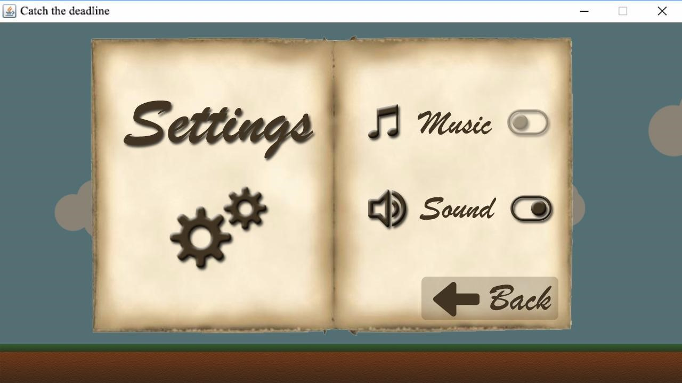

In the settings menu, user can turn off or on both music and the sound effects of the game.